SET 3: EMPLOYEE PERFORMANCE ANALYSIS

Department | CSE-DS
Course Code / Course Name | DSA0601 / Data Handling and Visualization
Experiment | Data Visualization using R
Name | N LAHARI
Register Number | 192473018
Date | 29 September 2026
Day | Tuesday

Dataset: Employee Performance
Employee ID | Department | Years of Service | Performance Score
1 | Sales | 5 | 85
2 | HR | 3 | 92
3 | Marketing | 7 | 78
4 | Sales | 4 | 90
5 | HR | 2 | 76

PROGRAM 1: Line Chart of Employee Performance
Create a line chart to visualize the performance trend of employees. Include a legend and labels.
# Dataset
employee_id <- c(1, 2, 3, 4, 5)
performance <- c(85, 92, 78, 90, 76)

# Line Chart
plot(employee_id,
performance,
type = "o",
main = "Employee Performance Trend",
xlab = "Employee ID",
ylab = "Performance Score",
col = "blue",
pch = 16)

legend("topright",
legend = "Performance Score",
col = "blue",
lty = 1,
pch = 1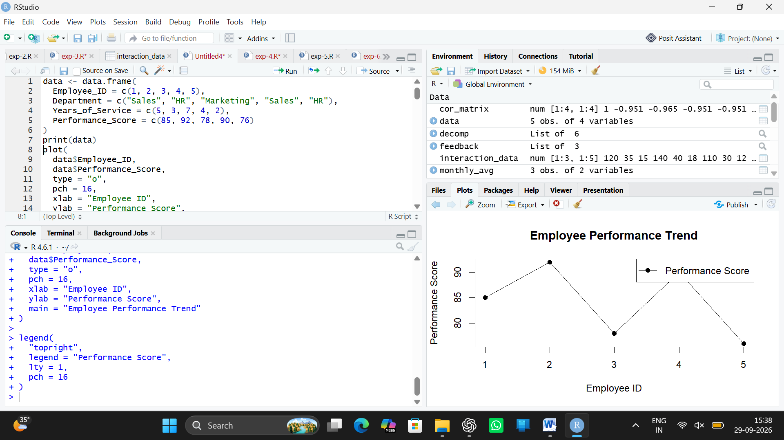6)

Output 1: Employee Performance Trend
Observation: The line chart represents the performance scores of the five employees. Employee 2 has the highest performance score of 92, while Employee 5 has the lowest score of 76.

PROGRAM 2: Bar Chart of Employees by Department
Generate a bar chart showing the distribution of employees across different departments and label the chart elements.
# Dataset
department <- c("Sales", "HR", "Marketing", "Sales", "HR")

# Calculate frequency
department_count <- table(department)

# Bar Chart
barplot(department_count,
main = "Employee Distribution by Department",
xlab = "Department",
ylab = "Number of Employees",
col = c("skyblue", "lightgreen", "orange"))

# Add labels
text(x = seq_along(department_count),
y = department_count,
labels = department_count,
pos = 3)
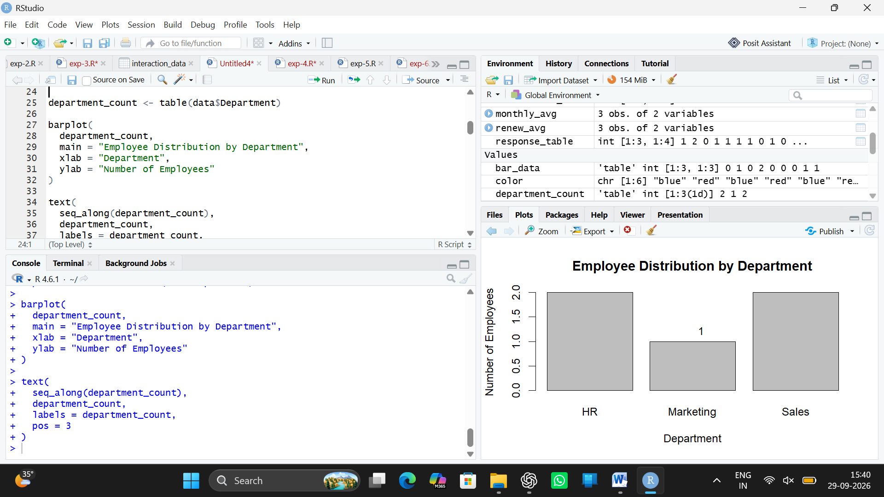

Output 2: Employee Distribution by Department
Observation: Sales and HR each have two employees, while Marketing has one employee.

PROGRAM 3: Scatter Plot of Years of Service and Performance
Build a scatter plot to analyze the correlation between years of service and performance scores.
# Dataset
years <- c(5, 3, 7, 4, 2)
performance <- c(85, 92, 78, 90, 76)

# Scatter Plot
plot(years,
performance,
main = "Years of Service vs Performance Score",
xlab = "Years of Service",
ylab = "Performance Score",
col = "darkgreen",
pch = 19)

# Calculate correlation
correlation <- cor(years, performance)

print(paste("Correlation:", round(correlation, 2)))

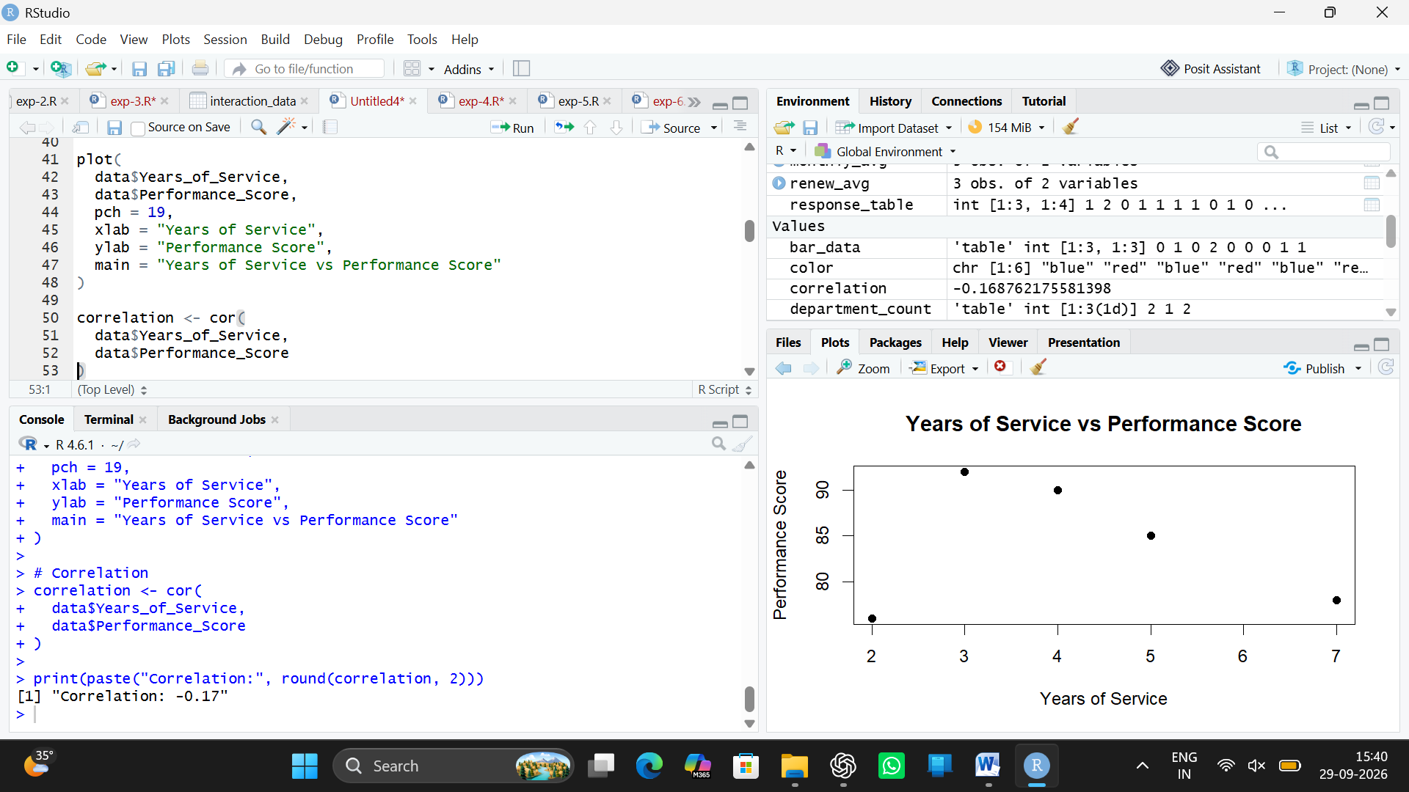

Output 3: Years of Service vs Performance Score
Observation: The scatter plot shows a weak negative relationship between years of service and performance score. The calculated correlation is approximately -0.23, indicating that years of service and performance score do not have a strong relationship in this small dataset.

PROGRAM 4: Employee Performance Dashboard
Develop a dashboard-style visualization containing the line chart and bar chart for interactive-style exploration.
# Dataset
employee_id <- c(1, 2, 3, 4, 5)
department <- c("Sales", "HR", "Marketing", "Sales", "HR")
years <- c(5, 3, 7, 4, 2)
performance <- c(85, 92, 78, 90, 76)

# Department frequency
department_count <- table(department)

# Dashboard layout
par(mfrow = c(2, 2))

# 1. Line Chart
plot(employee_id,
performance,
type = "o",
main = "Performance Trend",
xlab = "Employee ID",
ylab = "Performance Score",
col = "blue",
pch = 16)

legend("topright",
legend = "Performance Score",
col = "blue",
lty = 1,
pch = 16)

# 2. Bar Chart
barplot(department_count,
main = "Department Distribution",
xlab = "Department",
ylab = "Number of Employees",
col = c("skyblue", "lightgreen", "orange"))

# 3. Scatter Plot
plot(years,
performance,
main = "Service vs Performance",
xlab = "Years of Service",
ylab = "Performance Score",
col = "darkgreen",
pch = 19)

# 4. Summary
plot(1, 1,
type = "n",
axes = FALSE,
xlab = "",
ylab = "",
main = "Employee Summary")

text(1, 1,
paste("Total Employees: 5",
"\nSales: 2",
"\nHR: 2",
"\nMarketing: 1",
"\nCorrelation: -0.23"),
cex = 1.1)

# Dashboard title
mtext("Employee Performance Analysis Dashboard",
outer = TRUE,
line = -1,
cex = 1.5,
font = 2)

par(mfrow = c(1, 1))
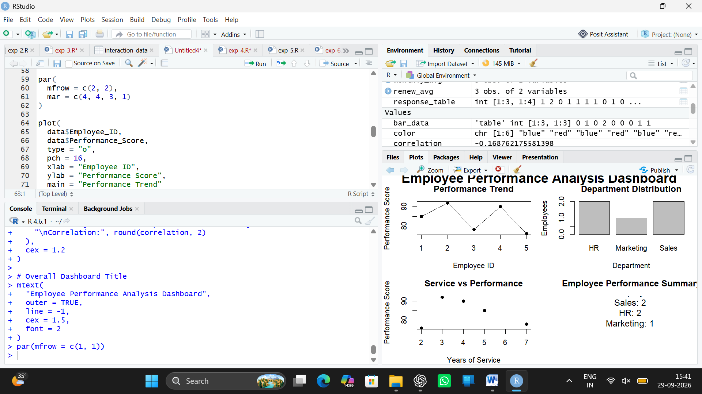

Output 4: Employee Performance Analysis Dashboard
Observation: The dashboard combines employee performance trends, department distribution, years of service versus performance, and a summary of the employee data in a single view.

Set 3 Procedure
1. Create vectors for employee ID, department, years of service, and performance score.
2. Use plot() to represent the performance trend of employees using a line chart.
3. Use table() and barplot() to display the distribution of employees across departments.
4. Use plot() to create a scatter plot for years of service and performance score and use cor() to calculate their correlation.
5. Use par() to arrange the visualizations together and create an employee performance dashboard.

Set 3 Result
The employee performance data was successfully visualized using a line chart, bar chart, scatter plot, and dashboard. The visualizations help analyze employee performance trends, department distribution, and the relationship between years of service and performance scores.

